





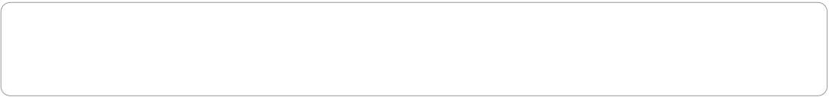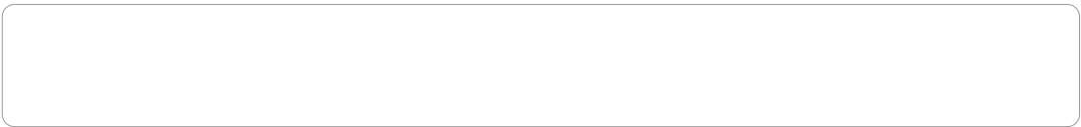



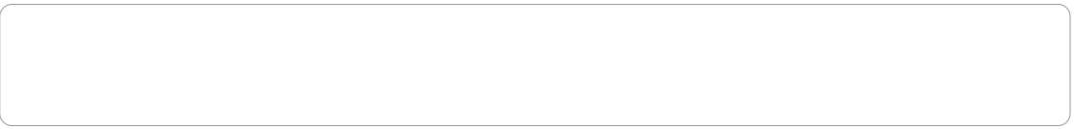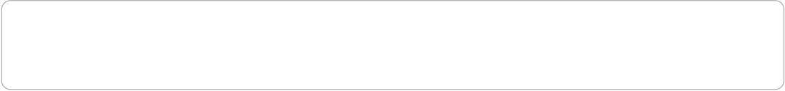



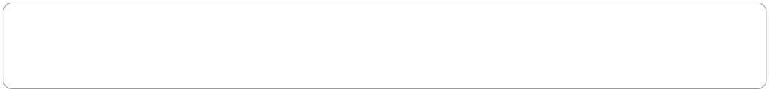

1. Output for area of triangle

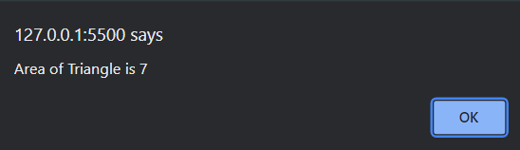

1. Output for area of rectangle

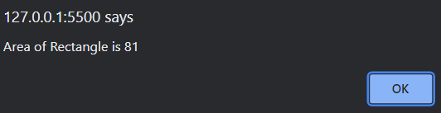

1. Output for area of circle

